

THE UNIVERSITY OF AZAD JAMMU AND KASHMIR, MUZAFFARABAD
STUDENT NAME: | SHAHZAD AHMED AWAN
STUDENT ROLL NO: | 2024-SE-15
LAB: | 02
COURSE TITLE: | Computer Networks
COURSE CODE: | CS-2203
INSTRUCTOR: | Engr. Dr. Asma Javaid
SUBMISSION DATE: | 06 March, 2026
Department of Software Engineering

Lab 02: Exploring Basics Concepts of Packet Tracer

Objective
To understand basic networking concepts, identify common networking devices, use Cisco Packet Tracer, and create a simple LAN to test connectivity between devices.

Step 1: Opening Cisco Packet Tracer
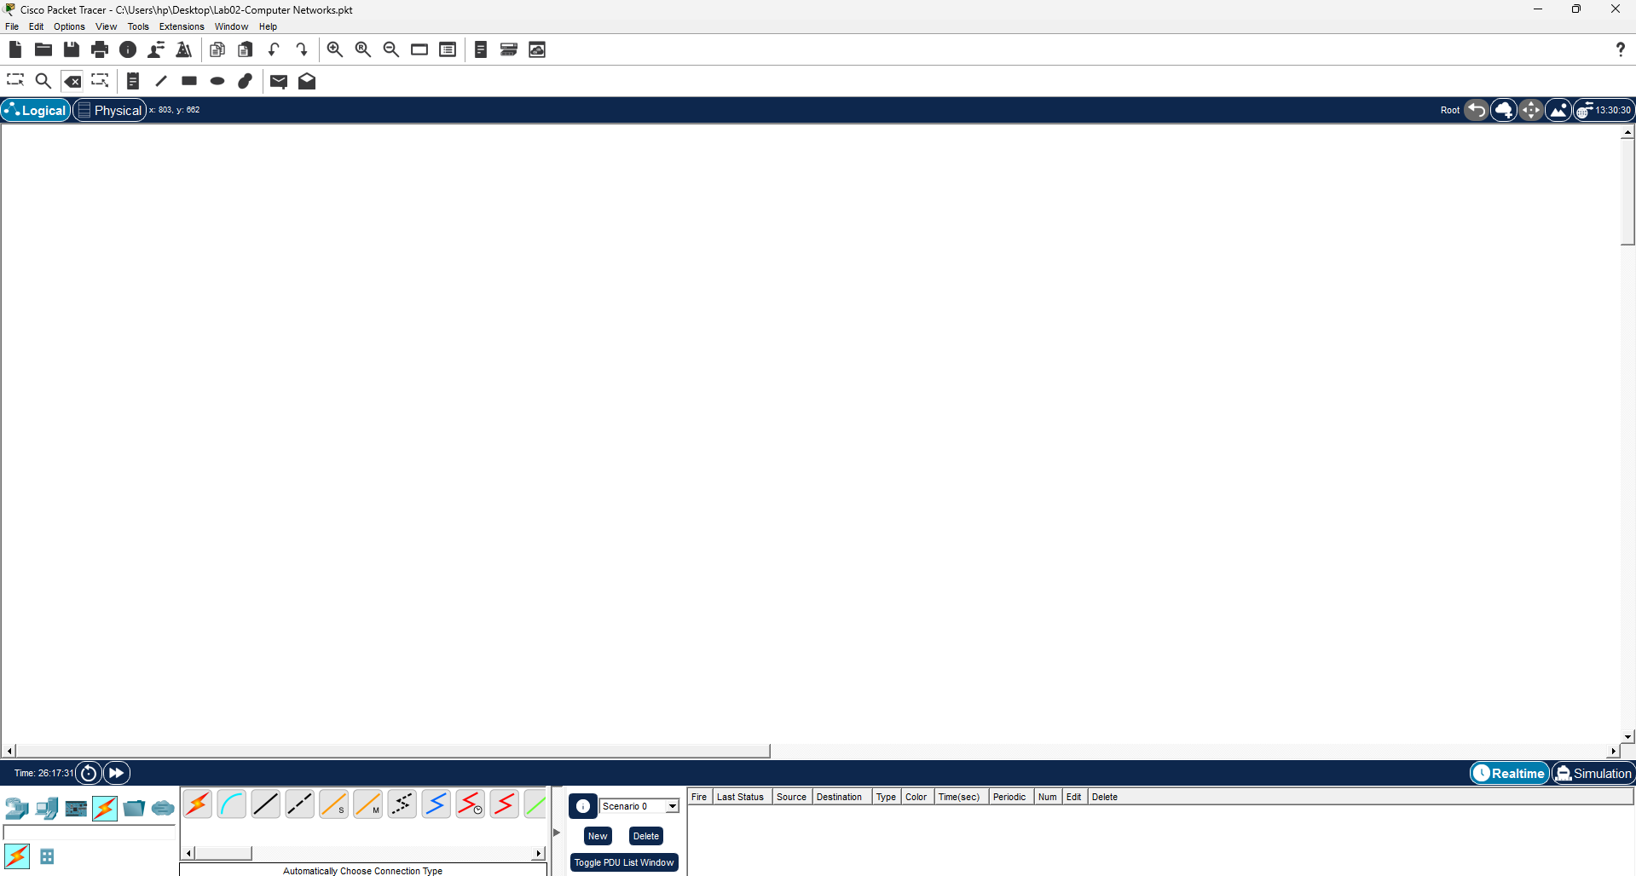
Open Cisco Packet Tracer from the system. The main interface appears showing the workspace, device panel, and connection tools.

Step 2: Adding a Switch
From Network Devices → Switches, drag a 2960 switch into the workspace. The switch will be used to connect multiple devices.

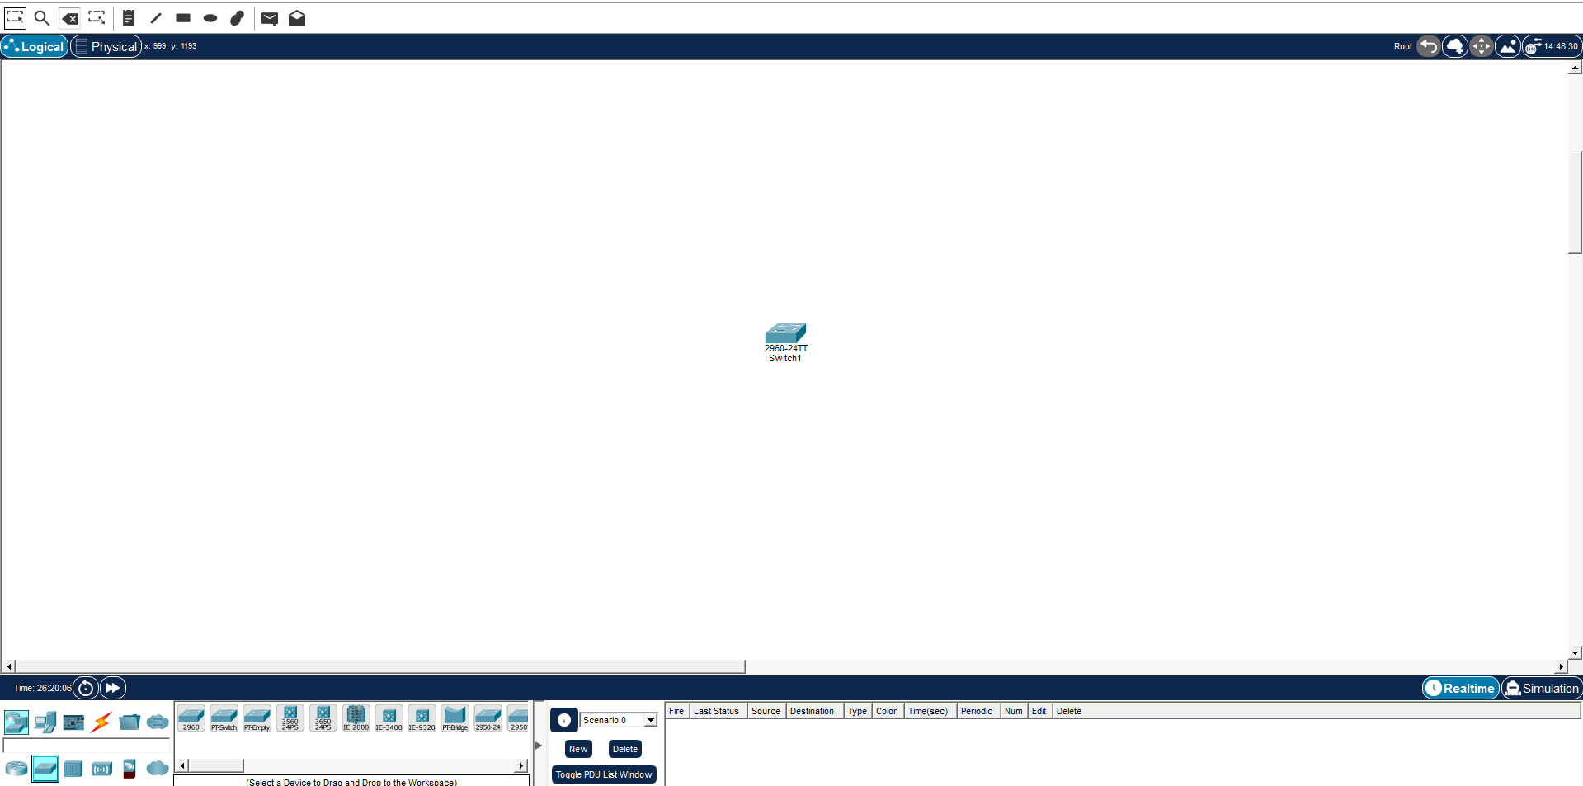Step 3: Adding End Devices
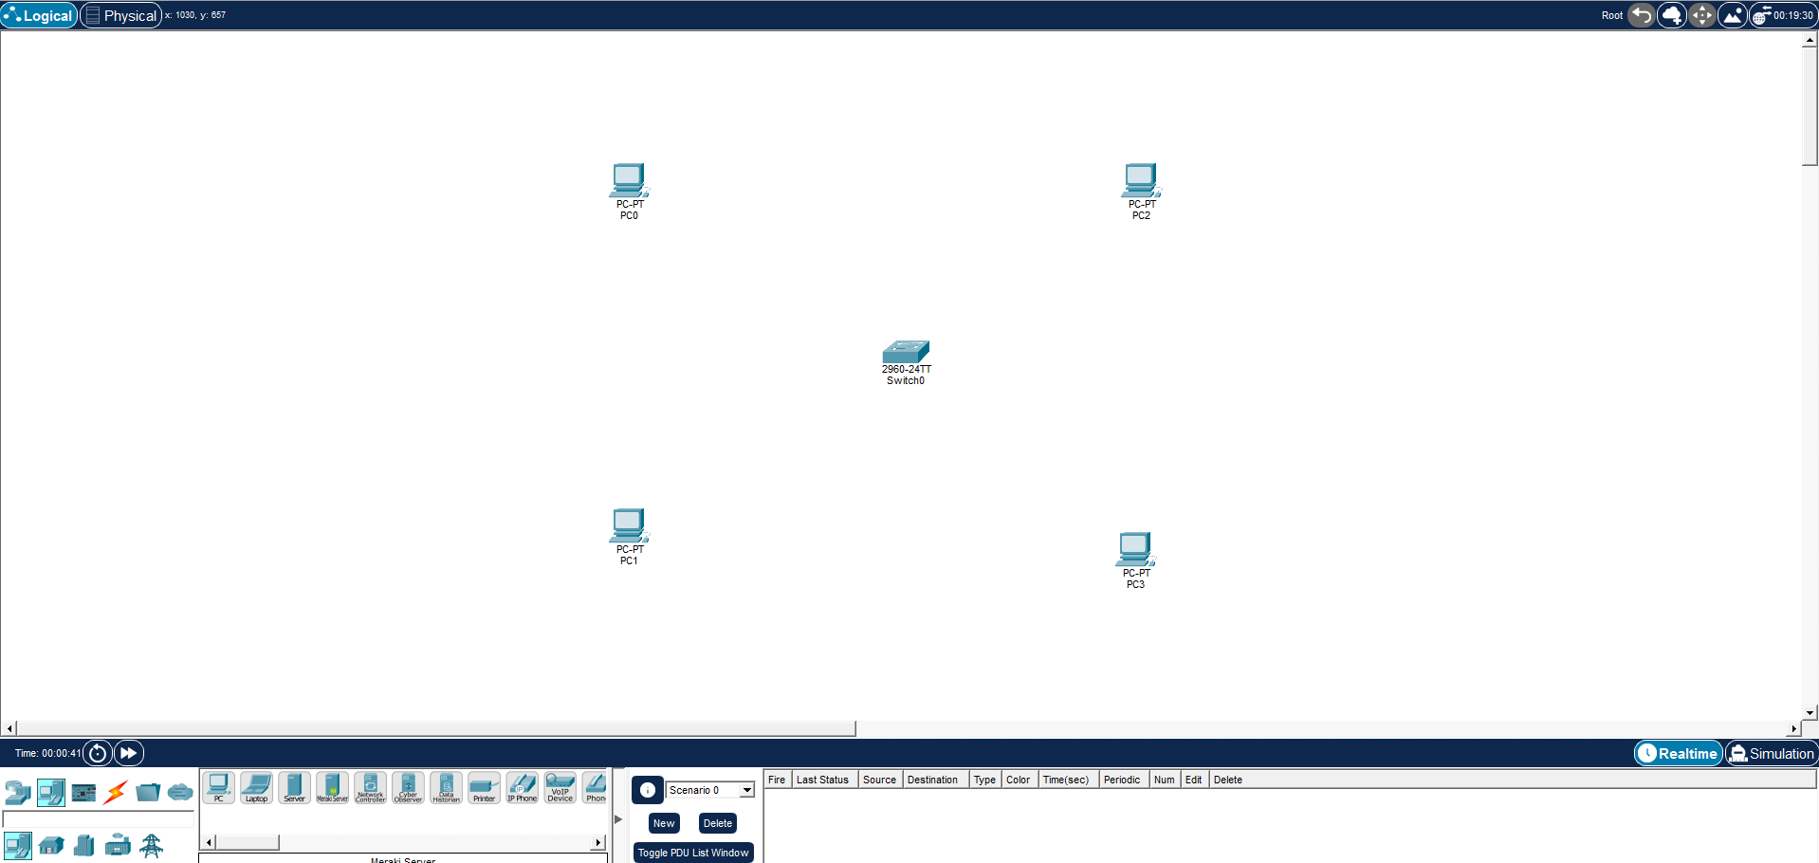
From End Devices, drag two PCs (PC0 and PC1…) into the workspace. These will act as hosts in the network.

Step 4: Connecting Devices
Select Automatically choose Connection type from the connections panel.
Connect:
- PC0 → Switch
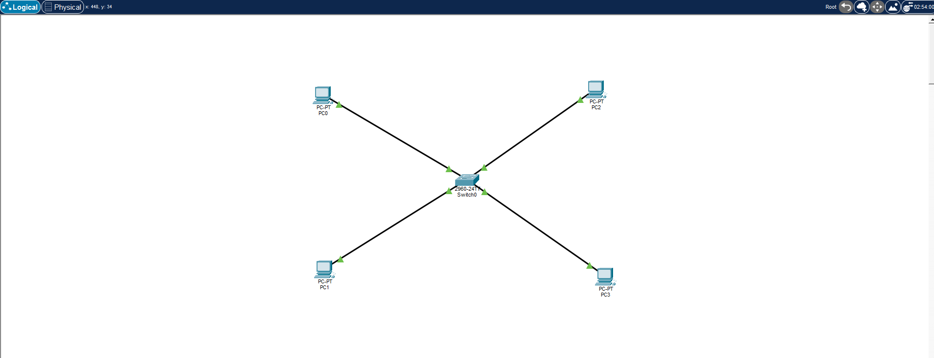
- PC1 → Switch

Step 5: Configuring IP Address for All End devices
Open PC0 …. P3 → Desktop → IP Configuration.
IP Address: 192.168.1.1 …
Subnet Mask: 255.255.255.0
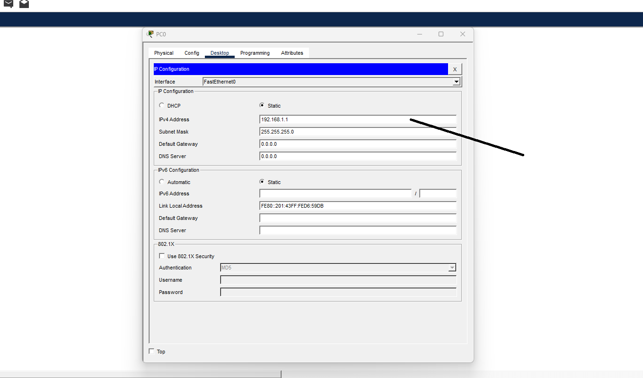

Step 7: Opening Command Prompt
Open PC0 → Desktop → Command Prompt to run network commands.
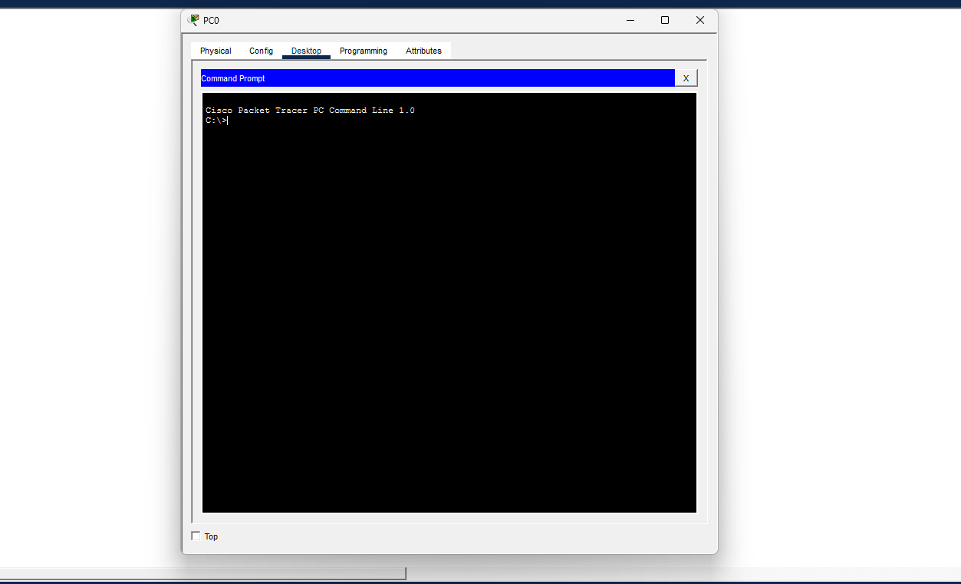

Step 8: Running ipconfig
Run:
ipconfig
This command displays the IP address and subnet mask configuration.
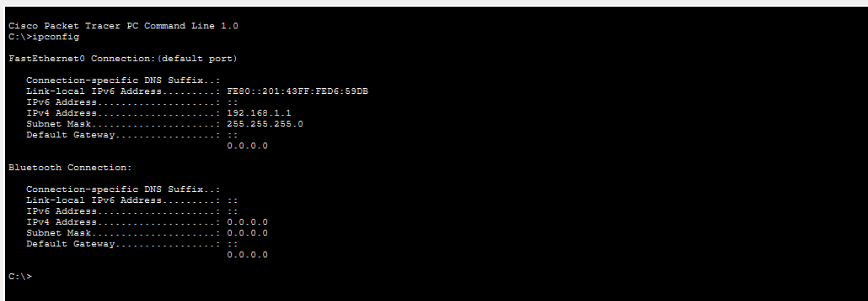

Step 9: Testing Connectivity using ping
Run:
ping 192.168.1.2
Successful replies confirm communication between the PCs.
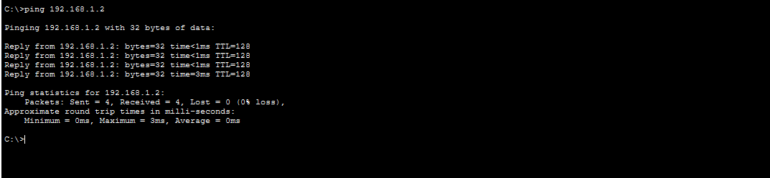

Step 10: Running tracert
Run:
tracert 192.168.1.2
This shows the path packets take to reach the destination.
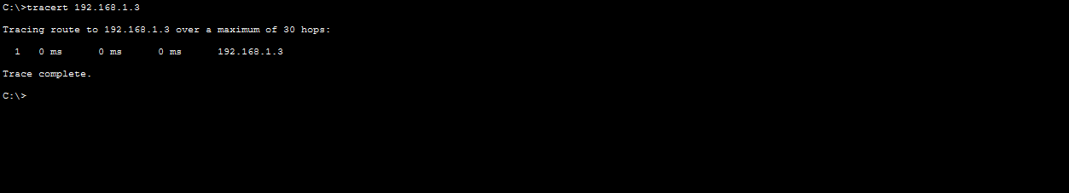

Step 11: Viewing ARP Table
Run:
arp -a
This command shows the mapping between IP addresses and MAC addresses.
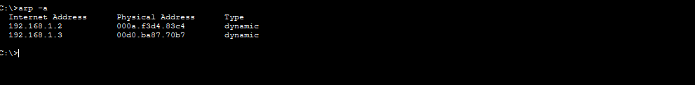

Step 12: Running netstat
Run:
netstat
This command displays network statistics and active connections.
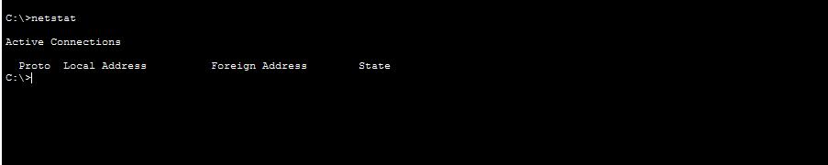

Conclusion
A simple LAN was created using Cisco Packet Tracer by connecting two PCs through a switch. IP addresses were configured, and commands such as ipconfig, ping, tracert, arp, and netstat were used to verify connectivity and analyze the network.

